# Unit 3: Do we find happiness in relationships and community?

## Overview



“No man is an island.”

John Donne (and much later, Jon Bon Jovi)

Figure 3.1. Image from <https://pixabay.com/en/island-holiday-caribbean-palm-trees-2482200/>

So far, we have thought about how society around us defines living a good life, and we have examined how finances play into our level of happiness. This week, we will wrestle with how our relationships with one another contribute to our experience of the good life. It’s no secret that humans were created to live in relationship with one another, and I’m sure you have experienced times of loneliness and isolation, maybe a sense of being displaced or neglected by others, maybe a belief that no one understands you. In order to think about these concepts in depth, we will focus on three stories and inquire through story-telling. We will look at the problems that arise when we limit others by a “single story” of who they are, and we will learn how coming to terms with our belongingness in our communities can lead to something more. Finally, we will listen to testimonies of people who experienced deep hurt from others, the consequences, and the pursuit of forgiveness. As John Donne wrote, “No man is an island,” so surely learning to love and care for one another has a role in the good life.

Before you begin the unit, consider the following questions:

* What does community mean?
* How does belonging to a community impact your identity?
* What creates and destroys healthy relationships?
* What connection(s) might exist between experiencing healthy relationships, belonging in a community, and happiness?

## Prompts

Unit 3 is divided into 3 prompts, or more accurately for this week, stories:

Story 1: The Danger of a Single Story

Story 2: Florence Osawamick: 12-year-old Pow Wow Dancer

Story 3: Truth & Reconciliation: Stories from Residential School Survivors

## Learning Outcomes

Through practicing inquiry in this unit, you will:

* Describe the nature of the relationship between human relationships, community, happiness, and the good life.
* Break down story inquiry from different forms of video presentation.
* Analyze and synthesize various perspectives
* Interpret meaning-making through story-telling
* Compare your experience to global and indigenous experiences of community
* Continue to examine your self-identity and your spiritual journey

## Activity Checklist

Here is a checklist of learning activities you will benefit from in completing this unit. You may find it useful for planning your work.

|  |  |
| --- | --- |
| 🗹 | **Activities** |
|  | Activity 1: Journal |
|  | Activity 2: Review the background of Adichie and her speech. |
|  | Activity 3: Watch the TedTalk. |
|  | Activity 4: Respond to the excerpts listed from the speech. |
|  | Activity 5: Review the background of the tradition of pow wow dancing |
|  | Activity 6: Watch the video: “Florence Osawamick: 12-year-old Pow Wow Dancer” |
|  | Activity 7: Review the background of the Truth and Reconciliation Commission |
|  | Activity 8: Watch the video: “Stories from Residential School Survivors” |

**Assessment**

Here is the assessment for Unit 3.

|  |  |
| --- | --- |
| **Group Discussion:** Do we find happiness in relationships and community?  *Note that the graded group discussion for this unit will focus on Prompt 3.* | 2% |
| **Inquiry Blog #1**: Respond to the posted question and interact with your classmates. | 2% |

## Prompt 1: The Danger of a Single Story

From a biblical perspective, we read that after the greatest commandment to seek and surrender to God, all other commandments and teachings relate to our interactions with one another through love. But what happens when we fail to understand others? When we judge and assume about others? What kinds of actions flow from a biased or limited perception? Can we experience “the good life” if our relationships and our community connections are built on a “single story?” In the TedTalk you’ll watch for this prompt, “The Danger of a Single Story,” Chimamanda Ngozi Adichie will challenge us to examine ourselves and our relationships.

### Learning Activities

### Activity 3.1: Reflective Journal

Spend approximately 5 minutes recording your thoughts on the quote, “No man is an island.” Do you see this concept in your own life? In your experience in different communities, such as family, school, work, and clubs?

### Activity 3.2: About Adichie

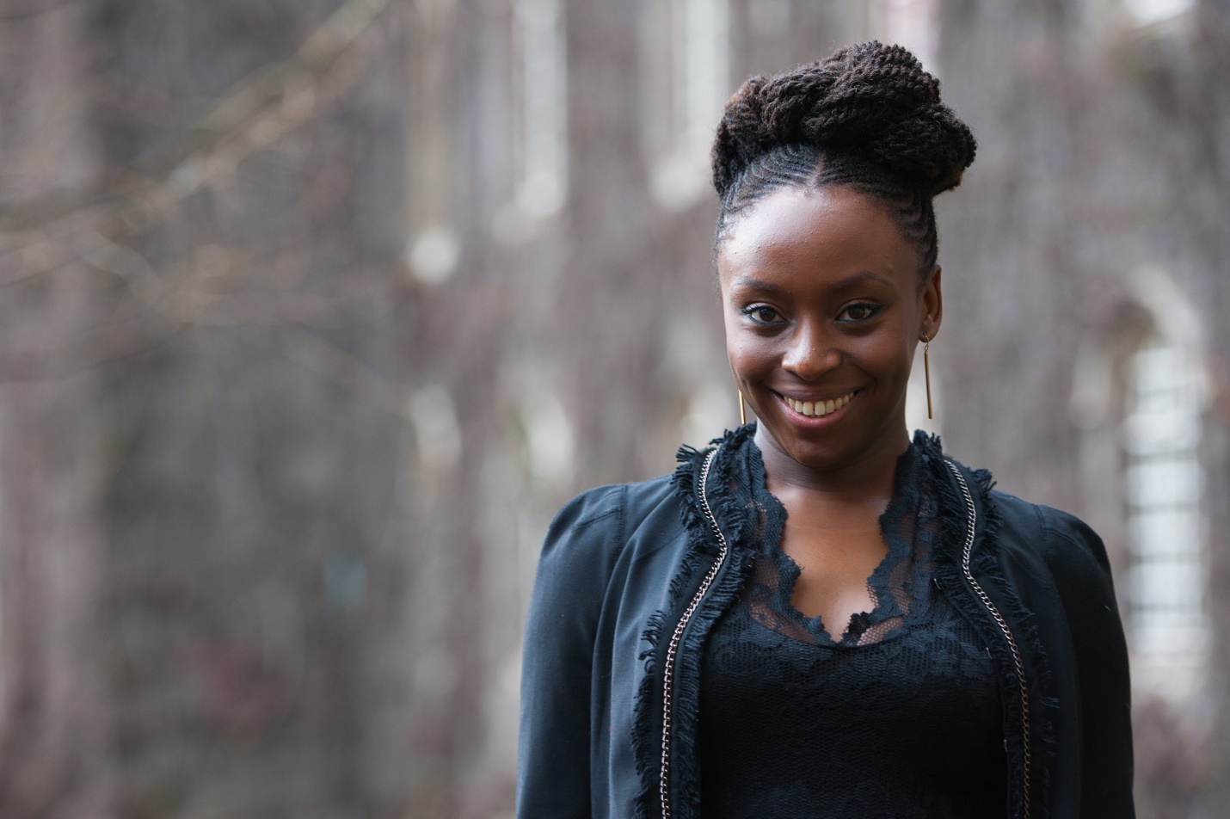Figure 3.2 "Chimamanda Ngozi Adichie - Cambridge April 2013" flickr photo by Chris Boland https://flickr.com/photos/chrisboland/8644307912 shared under a Creative Commons (BY-NC-ND) license

Review the background on Adichie to set the stage for your analysis of her speech.

**About Adichie**

Adichie is a Nigerian novelist (*Purple Hibiscus, Half of a Yellow Sun, Americanah, The Thing Around Your Neck*). She was born in 1977, a few years after the Biafran War (1967-1970) in Nigeria and came to America at age 19 for university. She grew up attending Catholic mass in Nigeria but became agitated by it:

“I was alienated by the Church’s emphasis on money-collection, the swaggering power of priests, the heaving gap between doctrine and the lived lives of people. Here was a Church afraid of itself, of looking inward, which instead basked in hollow certainties” (Adichie, 2015)

**Her writing and her beliefs:**

* Her work considers what it means to be both Nigerian and American, the immigrant identity and the African experience
* She explores how people shape one another.
* She does not like to say that she is influenced by any particular writer, but she does acknowledge the connection to Chinua Achebe, who is known as the father of African fiction.
* Adiche does not like the idea of labels such as “African writer” or “Black writer”
* She says, “Diversity does not have to mean division” (Social media post, as cited in [The Guardian](https://www.theguardian.com/books/2017/mar/13/chimamanda-ngozi-adichie-clarifies-transgender-comments))
* She is a well-known feminist, and she speaks in support of the LGBT community. See her essay, “[We should all be feminists](http://www.4thestate.co.uk/book/we-should-all-be-feminists/).”

Although Adichie does not address relationship in biblical terms, she challenges us to examine how our assumptions and biases limit our ability to see other people fully and to build healthy relationships.

### Activity 3.3: TedTalk video

In this activity, you will watch [“The danger of a single story”](https://www.ted.com/talks/chimamanda_adichie_the_danger_of_a_single_story) from a 2009 filming of TedGlobal. Adichie’s speech is intended for a global audience and is not situated within any particular context or event. The genre of a personal speech allows her to express her own experiences and share what she has learned, and she brings the perspective of cultural and national identity.

Go to Adichie’s TedTalk found at <https://www.ted.com/talks/chimamanda_adichie_the_danger_of_a_single_story> and watch the full speech. You can also follow along with the transcript.

### Activity 3.4: Response

After you have watched the talk, consider the six excerpts below and write your responses in your reflective journal. You may wish to discuss your thoughts with your group at your weekly meeting.

*Note that as with all of the first lesson prompts, you will* ***not be graded*** *on these discussions. This prompt will help you explore the topics and will be instrumental in completing the final project.*

|  |
| --- |
| **Excerpt #1**  **“What this demonstrates, I think, is how impressionable and vulnerable we are in the face of a story, particularly as children. Because all I had read were books in which characters were foreign, I had become convinced that books by their very nature had to have foreigners in them and had to be about things with which I could not personally identify. Now, things changed when I discovered African books. There weren't many of them available, and they weren't quite as easy to find as the foreign books.”** |

*Questions to Consider:*

* How can our entertainment experiences (books, movies, TV) shape our understanding of other people?
* What kinds of stories shaped you in your childhood? Did you see yourself in the stories?

|  |
| --- |
| **Excerpt #2**  **“Then one Saturday, we went to his village to visit, and his mother showed us a beautifully patterned basket made of dyed raffia that his brother had made. I was startled. It had not occurred to me that anybody in his family could actually make something. All I had heard about them was how poor they were, so that it had become impossible for me to see them as anything else but poor. Their poverty was my single story of them.”** |

*Questions to Consider:*

* What single stories do you have about others?
* How do you think holding onto single stories could impact your relationships with others? How might it intersect with “the good life?”

|  |
| --- |
| **Excerpt #3**  **“What struck me was this: She had felt sorry for me even before she saw me. Her default position toward me, as an African, was a kind of patronizing, well-meaning pity. My roommate had a single story of Africa: a single story of catastrophe. In this single story, there was no possibility of Africans being similar to her in any way, no possibility of feelings more complex than pity, no possibility of a connection as human equals.”** |

*Questions to Consider:*

* Think of a time when you held a “single story” image of someone and it proved to be completely wrong.
* What does “feeling sorry for someone” do to the relationship?

|  |
| --- |
| **Excerpt #4**  **Power is the ability not just to tell the story of another person, but to make it the definitive story of that person. The Palestinian poet Mourid Barghouti writes that if you want to dispossess a people, the simplest way to do it is to tell their story and to start with, "secondly." Start the story with the arrows of the Native Americans, and not with the arrival of the British, and you have an entirely different story. Start the story with the failure of the African state, and not with the colonial creation of the African state, and you have an entirely different story.** |

*Questions to Consider:*

* How does being an insider or outsider to a community affect the way you tell that community’s story?
* Do you find happiness in the way your community’s story is told?

|  |
| --- |
| **Excerpt #5**  **All of these stories make me who I am. But to insist on only these negative stories is to flatten my experience and to overlook the many other stories that formed me.** |

*Questions to Consider:*

* Do you tend to identify yourself within your negative stories? Or within your positive stories? Are there stories of yourself that you ignore?
* How does your self-image impact your relationships?
* What about the identities you assign to others?

|  |
| --- |
| **Excerpt #6**  **The consequence of the single story is this: It robs people of dignity. It makes our recognition of our equal humanity difficult. It emphasizes how we are different rather than how we are similar.**  **Stories matter. Many stories matter. Stories have been used to dispossess and to malign, but stories can also be used to empower and to humanize. Stories can break the dignity of a people, but stories can also repair that broken dignity.** |

*Questions to Consider:*

* Is there a story that has robbed you or someone you know of dignity?
* How can you restore dignity to someone’s story?

## Prompt 2: Florence Osawamick: 12-year-old Pow Wow Dancer

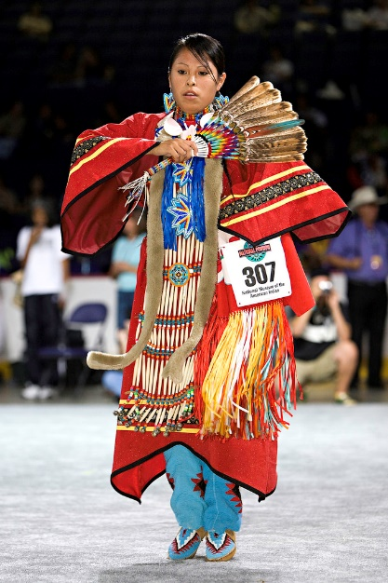

Figure 3.3 "2007 Powwow" flickr photo by Smithsonian Institution <https://flickr.com/photos/smithsonian/2535895581> shared with no copyright restriction (Flickr Commons)

Adichie’s talk gives a critical lens to human relationships, but in this short video story of a young pow-wow dancer, we hear the other side, how Florence experiences belongingness in her cultural community through active participation.

Although this short interview is from a child’s perspective, it leads us to consider membership in community and a sense of belonging. For your group discussion, you will combine Florence’s story with Prompt 3 in order to understand the Canadian indigenous community better – that it isn’t a single story.

### Learning Activities

### Activity 3.5: Pow-Wow Background

A Pow-Wow is an indigenous community festival to celebrate the culture and traditions through dance, music, art, and food. Pow-wows also have a component of healing.

Read the following information on the traditions of the pow-wow to provide some additional context.

**Background:**

* Pow-wows may have started in the 1800s or early 1900s to celebrate a hunt, to honour people, and for naming ceremonies (McCluskey, 1995)
* A way to celebrate but also preserve traditions during a time of movement to reserves
* With people living in small communities together, the dances and music soon took on unique variations.
* The 1876 Indian Act in Canada restricted pow wows, traditional foods and clothing, and spiritual practices, but some communities continued to practice in secret. Restrictions were lifted in 1951, and pow wows became vibrant throughout the 1960s.
* Modern Pow Wows may include competition.

**Dances:**

* “Dances include men's and women's traditional dance, men's and women's fancy dance, men's grass dance, sneak-up dance, war dance, jingle dress dance, round dance, intertribal dance, and ceremonial dances” (McCluskey, 1995).
* Traditional Dance: Women wear beaded regalia with symbolic meaning and may carry a fan or feather. The dance is almost stationary with bending at the knees and twisting.
* Jingle Dance: Women wear a jingle dress which has hundreds of metal jingles sown into it. Women must dance in sync with the music and stop with two feet on the ground when the music stops. This dance comes from a story of healing and represents the healing of women’s wounds, the healing promise of the Creator (Miller, 2006).

**Role of the pow wow**

* “The legacy of Canadian colonial relations has wreaked havoc on indigenous peoples and continues to do so,” says anthropologist Dr Jane McMillan, of St Francis Xavier University, Nova Scotia. “The return to the drum, to singing and dancing is not just a solace but a form of resistance” (cited in Cleveland-Peck, 2007).

### Activity 3.6: Video

Watch the short video “[Florence Osawamick: 12-year-old Pow Wow Dancer](http://www.cbc.ca/player/play/1230042691915)”.

In this video, Florence refers to the jingle and women’s traditional dances. As you watch, consider how her participation in pow wow dancing impacts the quality of her life through community.

*Note that the group discussion for this unit will be on Prompt 3.*

## Prompt 3: Truth & Reconciliation: Stories from Residential School Survivors

One of the dark shadows of Canadian history is the practice of removing aboriginal children from their homes and placing them in a residential school, where the administrators tried to take away all signs of the children’s cultural identities, including their names, language, traditions, beliefs, and ways of life. Communities that were once healthy, where people could seek and experience “the good life,” became broken. The chronic trauma that resulted from life in residential schools has impacted our indigenous communities for generations. In this short documentary, we will listen to the stories of people who have experienced the impact of residential schools on their relationships in family and community, and we will also listen to their beliefs about forgiveness. In your groups, you will have the opportunity to discuss what you have heard as it relates to the role of relationships and community in our pursuit of happiness.

### Learning Activities

#### Activity 3.7: Residential Schools and the Truth and Reconciliation Commission

Review the background information below on Residential Schools and the Truth and Reconciliation Commission as context for these stories.

**Residential Schools:**

* Residential school system was set up in the 1880s by the government of Canada but carried out by the church.
* Although one purpose was to provide education, the more significant purpose was to “take the Indian out of the child” and assimilate the children into mainstream culture and Christianity. This came out of a colonial mindset that viewed the indigenous as inferior and “savage.”
* Children were forcibly removed from their families and prevented from having contact with them.
* They were punished for violations such as using their language. Many experienced abuse, and many died.
* Without a family environment, the children did not learn how to function in a family and this led to generations of social issues.
* The last residential school closed in 1996.

**Truth and Reconciliation Commission:**

* Began June 1, 2008 with the purpose of giving voice to the victims, recording their stories, and producing a report of recommendations.
* Also gave access to millions of documents in the possession of the Canadian government
* The Commission lists 94 Calls to Action toward reconciliation and renewal of the vitality of the indigenous peoples.
* Full details are available on [the commission’s website](http://www.trc.ca/websites/trcinstitution/index.php?p=890).

### Activity 3.8: Testimonies

In this short video, you will hear the testimonies of one group in their journey towards reconciliation. Watch the story, [Stories of Residential School Survivors](https://www.youtube.com/watch?v=VmjrVfsLRBE) found at <https://www.youtube.com/watch?v=VmjrVfsLRBE>.

As you watch, think about the meaning of relationship and community, and ponder what these testimonies tell you about the good life.

## Assessment

### Group Discussion: Do we find happiness in relationships and community?

Meet with your group this week to share your thoughts and challenge others. What do the prompts reveal to you as you consider the question, “Do we find happiness in relationships and community?” Complete the Group Discussion Template together (Google Docs) and post the link as a record of your group’s discussion of **Prompt 3**.

### Inquiry Blog #1: Choose ONE of the following topics.

This is the first of 5 Inquiry Blog assignments you will complete for this course. For this blog, you have two options:

Choose one community that you are a part of (such as church, team, volunteer organization, young adults group, neighbourhood, club, dorm). Describe the community. Do you feel a sense of belonging and how do you know? In what ways has being a member of the community helped you? What difficulties have you observed or experienced in the community? What does this community show you about our question, “What is the good life?” Write approximately 500 words and post it to the forum.

OR

Go to the website [Humans of New York](http://www.humansofnewyork.com/). On the homepage, you will see a number of brief stories of people’s lives. Choose four stories to read, and write your forum post as a response. What do these stories tell you about the relationship between relationship/community and the good life? What impacts the level of happiness in these stories? Write approximately 500 words and post it to the forum.

## Unit 3 Summary

In this unit, we have focused on inquiry through oral story-telling in the form of video. Adichie reminds us that in order to build relationship, we cannot define people by a “single story,” a story that has “no possibility” of certain events or characters, a story that limits “our connection as human equals.” The story of the young pow-wow dancer shows one story of community for indigenous people of Canada. The stories of residential school survivors show another part of the story. These three stories are only a beginning point for your inquiry. As you continue in this course, you will encounter more stories that will expand your understanding and your ability to connect to other people as you think about the meaning of “the good life.”

## References

* Adichie, C.N. (2015, October 14). Raised Catholic. *The Atlantic*. Retrieved from <https://www.theatlantic.com/international/archive/2015/10/catholic-pope-francis-chimamanda-adichie/409237/>
* Chimamanda Ngozi Adichie clarifies transgender comments as backlash grows. (2017, March. 13). The Guardian. Retrieved from <https://www.theguardian.com/books/2017/mar/13/chimamanda-ngozi-adichie-clarifies-transgender-comments>
* Chimamanda Ngozi Adichie website. University of Liège. Retrieved from <http://www.cerep.ulg.ac.be/adichie/index.html>
* Photos: [www.chimamanda.com](http://www.chimamanda.com/)